**ONE WEEK TRAINING WORKSHOP ON**

**MODEL MAKING-A TOOL OF EXPRESSION IN**

**URBAN AND REGIONAL PLANNING**

**From 18-22 February, 2014 at**

**Institute of Geography, Urban and Regional Planning**

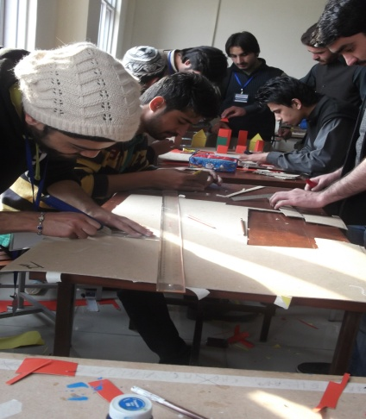

**Workshop Organizers**

|  |  |  |
| --- | --- | --- |
| **Institute of Geography,**  **Urban and Regional Planning Program**  C:\Users\Usman Ali\Desktop\Uop_seal.jpg**University of Peshawar** | **Urban Policy Unit,**  **Planning and Development Department**  **Government of Khyber Pakhtunkhwha**  http://www.urbanpolicyunit.gkp.pk/logo.jpg | **United States Agency for International Development (USAID), Pakistan**  **USAID/Pakistan** |

**ONE WEEK TRAINING WORKSHOP ON MODEL MAKING-A TOOL OF EXPRESSION IN URBAN AND REGIONAL PLANNING**

**From 18-22 February, 2014 at Institute of Geography, Urban and Regional Planning,.**

**Introduction**

Model making in development planning is an essential tool to depict an idea in a physical format in order to have the actual feeling of any change in the built environment because the change in land use. Planning models are [scale](http://en.wikipedia.org/wiki/Scale_model) and tangible representation of any development (structure) built to study various aspects of an urban planning/[architectural design](http://en.wikipedia.org/wiki/Architecture) or to communicate design ideas to clients, committees, and the general public. Planning and architectural models are a tool which may be used for show, presentation, fund raising, obtaining permits and sale purposes.

Models can be made quickly using cardboard, wooden blocks, polystyrene, foam, foam boards and other materials. Such models are an efficient tool for three-dimensional understanding of a design, used by urban planners, architects, interior designers and exhibit designers. For a highly detailed presentation model, urban planners/architects would employ a professional model maker, model making company or students working for credit.

**Purpose**

Models are sometimes made to study the interaction of volumes, or to get an idea of how they look from different angles. Designing a building using rough models can be a very open-ended and practical method of exploring ideas. Models are an efficient method for exhibiting and selling a design. Many people, including developers and would-be house buyers, cannot visualize a design in three dimensions (3-D) from two-dimensional (2-D) drawings. A planner may employ small-scale physical models, or digital computer models, to help explain their ideas.

A model may be useful in explaining a complicated or unusual design to the building team, or as a focus for discussion between the design teams such as town planners, architects and engineers. Models are also used as show pieces, for instance as a feature in the reception of a prestigious building, or as part of a museum exhibition (for example scale replicas of historical buildings).

**Objective of the workshop**

Through this workshop participants will learn and explore different aspects of model making and its use in their field

* It will enhance their ideas about the correlation of various features of the built environment.
* It will also promote the participants to put their concepts in a physical form.
* will give them better understanding about the scale, spaces and different activities within a city.
* They will learn different techniques and ideas of model making likewise drafting, cutting, pasting, assembling, form composition etc.
* They will learn a new medium to express their selves.
* Will get a better understanding about town planning and spatial distribution.
* They will get a better understanding about the correlation of spaces and volumes and play a vital role in their upcoming professional career.

**Organizers:**

1. Institute of Geography,

Urban and Regional Planning Program

University of Peshawar

1. Urban Policy Unit,

Planning and Development Department

Government of Khyber Pakhtunkhwa

1. United States Agency for International Development (USAID), Pakistan,

**Contact Person**:

Engr./Plnr S. Akhtar Ali Shah

Coordinator, Urban and Regional Planning,

University of Peshawar

[shahg@upesh.edu.pk](mailto:shahg@upesh.edu.pk)

Ph: 03005901110

**Proceedings of the Workshop**

**Day one:** Timing: 9am -4:30 pm

**Session I-Opening ceremony- 9: 00am-10.30am ;**

The workshop commenced with the recitation of Holy Quran by Student Ali Shah. In the opening session students of Urban and Regional Planning as well as nominee of the Provincial government from line departments as well as educational institutes of the University were present. Prof Dr Amir Nawaz Khan, Dean Faculty of Life and Environmental Sciences Chaired the opening session.

Dr. Akhtar Ali Shah, Coordinator, Urban and Regional Planning welcomed the guests and gave a brief presentation about the purpose of the workshop explaining its significance and relevance to Urban and Regional Planners, decision makers and students.

*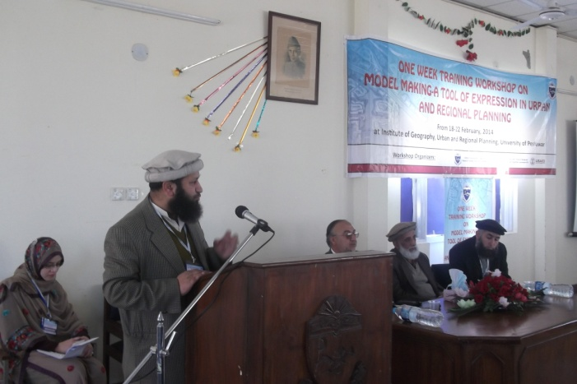*

**Dr. S. Akhtar Ali Shah addressing the chief Guest and participants of the workshop**

**Session II 12:00-2-00PM**

**Day one:**

* 10.30-11.00 am Tea Break
* 11.00-11:30am Formation of groups
* 11:30am-12:00am Image of a city Dr S. Akhtar Ali Shah
* 12:00pm-12:30pm Urban design Prof. Dr Aslam Khan
* 12:30pm-1:00pm Drafting techniques for model making, Arc. Arshad Ali
* 1:00pm -2:00pm Lunch and prayer break

The second session started after a tea break, different expert, professional architects as well as planners were invited to the workshop. They discussed importance of the workshop subject and share their knowledge with students and other participants. There was question and answer session between the students and the experts which was helpful for students in understanding the subject and overall objectives of the workshop.

Guest list is following

* Prof Dr. Aslam
* Arch Arshad Ali (CEO EADC)
* Arch Fehmeed Ullah Shah (Chairman Department of Architecture, Hazara university)
* Arch Abdul Waheed Khan
* Arch Ilyas Ahmad
* Plnr. Muhammad Bilal (UPU)

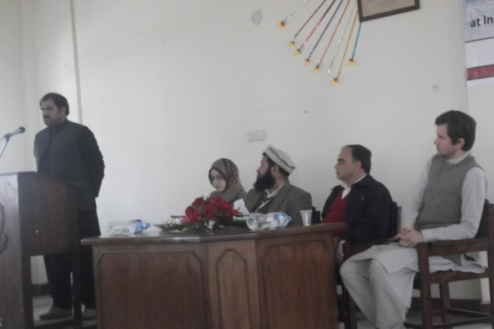

**Arch Arshad Ali discussing different uses of physical models.**

**Session III 2:00 pm 4-30 pm**

Session three was dedicated towards learning the basics of modeling wherein the participants were briefed about learning basic skills of model making that included Drafting, Cutting and Pasting. Techniques for making different geometrical shapes like cube, cone, cylinder, hexagon, rectangle etc. were taught. After tutorial session of model making tools and materials were distributed among the groups to practice making these shapes.

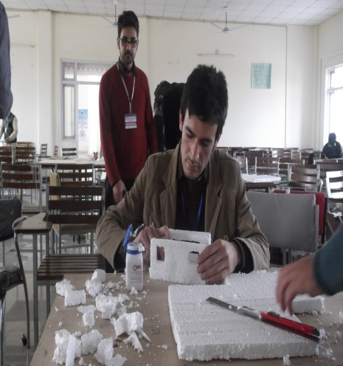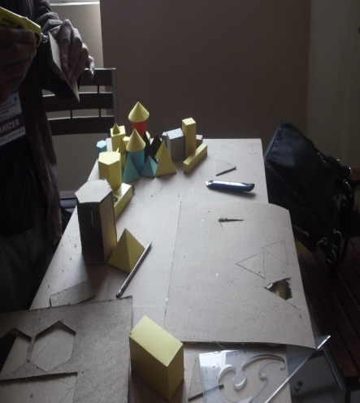

**Participants working to learn techniques of model making on different materials**

**Day II Date: 19/02/2014**

* 9:00am-10.00 am Demonstration (Proper cutting techniques of different materials) Arch Ilyas
* 10.00am-10:30am: - Tea Break
* 10.30am-12:00: - Urban models Arc Fahmidullah Shah
* 12:00pm-1:00 pm - Classic and digital architecture Arch Sanan
* 1:00pm-2:00pm: - Lunch and prayer break
* 2:00-4:30: - Practical demonstration on pasting

On this day cutting and pasting techniques of different materials like card board, box card, thermo pole sheet, balsa wood and plastic sheets were taught. Lectures were delivered on various aspects of urban design and digital architecture. Renowned architects and planners visited the workshop. They appreciated interest and enthusiasm shown by the participants and gave some useful suggestions about the model making techniques.

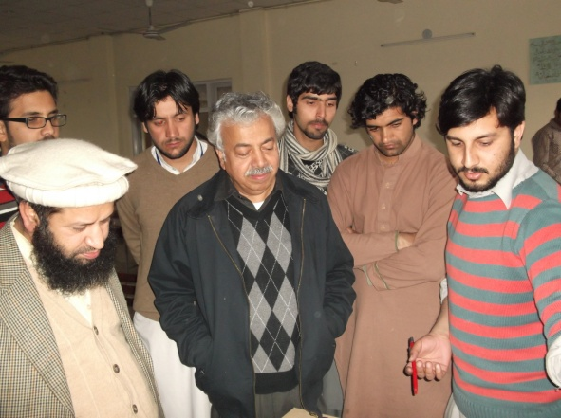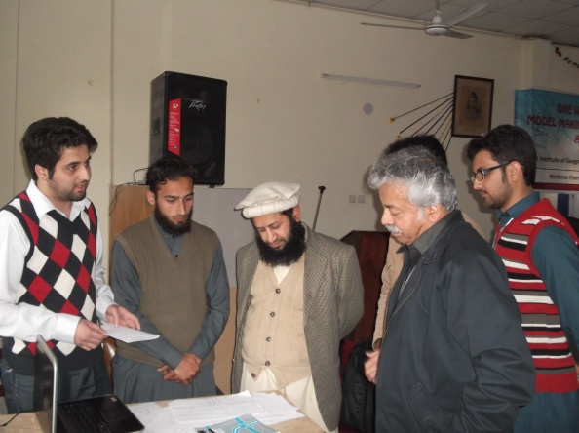

**Plnr. Abdul Haleem Paracha, Director PDA visiting the workshop**

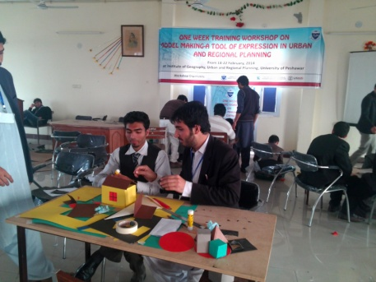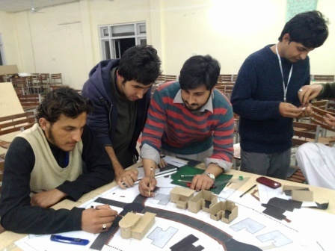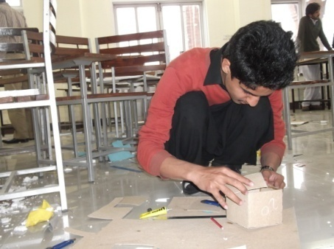

**Participants of the workshop working with models**

**Day III Date: 20/02/2014**

Timing: 9:00am -5:00am

Trip inside the Peshawar city (Historical places), Modern developments; Visit to Regi Lalama township scheme under the supervision of Dr S. Akhtar Ali Shah, Arch Ilyas, Arch. Sanan, Plnr. Nasir Ali, Arch. Shukat Ali

Workshop students were taken out in the field to see different sites in Peshawar city that included:

* Regi Lalama Township Scheme, on Nasir Bagh Road
* Tehsil *Gore Gathri*
* Sethi house
* Mohala Baqir shah and Saitheian
* Other areas in the vicinity of Clock tower (*GHANTA GHAR*)

The purpose of the visits was to understand urban structure both in modern developments as in case of Regi Lalama Township scheme as well as in more classical setup as is the case of old city. The intention was to provide an opportunity to the participants of the workshop to get a firsthand knowledge of urban forms and have a look of all the major elements that make up a city that include but not limited to physical features like roads, paths, boundaries, nodes and landmarks. All these elements were prominent in the Master plan of the Regi Lalama Township Scheme that was seen and briefed by the Coordinator Dr. S. Akhtar Ali Shah at the site office of the Township. The project staff of Peshawar Development Authority (PDA) also facilitated the participants and answered different queries of the participants regarding the process of development and facilities available in the Scheme. The PDA project staff also guided the tour of the Township wherein different facilities like sports complex, parks etc. were visited.

Sethi house and surrounding areas were visited to understands the classical architecture in the city and give the participants an inspiration from the indigenous built environment compatible with the socio cultural norms. Immediately after visiting Regi Lalma township scheme with broad roads and lavish outlook the old city visit with higher population density, commercial hustle and bustle and social propinquity was of great value and liked and admired by the participants. The experience helped the participants to understand the use of space on centuries old footing of experience and exposure. Few pictures of the trips are shown below.

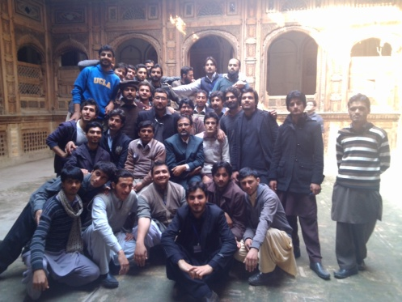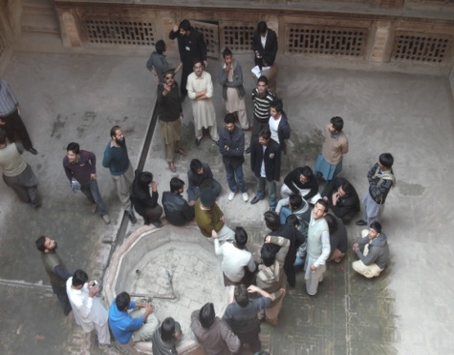

arr

**A group of participants in Sethi house**

s

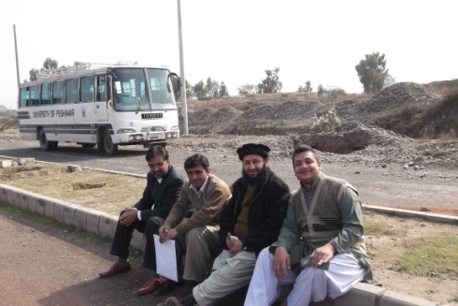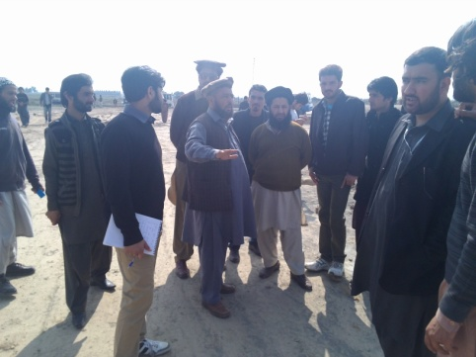

**Visit of Regi Lalama Township Scheme**

**Day IV Date: 21/02/2014**

**Day Four:- Mentors**  Dr S. Akhtar Ali Shah, Arch Ilyas, Arch. Sanan, Plnr. Nasir Ali, Arch. Shukat Ali

**Timing**: 9am- 1:00 pm Group Assignment

2:00pm-4:00pm: -Group discussion+ demonstration+ composing

4:00pm-5:00pm: -Detailing of final model+ Lab activity (pasting)+ assessment

The last two days of the workshop were dedicated for the individual exercises/task based upon their perception of the spatial settings and learning during the last three days. Thus on the fourth day of the workshop the participants were asked to make a project hovering around any specific spatial/ land use related problem or creating an altogether new built environment of their liking with the help of sketches and models. Initially all ten groups discussed their ideas with their tutors individually and after a thorough discussion and finalized an area to work upon. After fixing the project, some essential model making materials were provided to the participants while for any specialized material, a local supplier was given a space within the hall where he established a small stall and provided it at the market rates. The participants enjoyed working with spaces and modeling physical features and worked till 9 pm in the evening. Some of the prepared models are shown below in pictures.

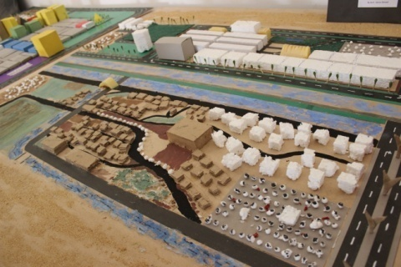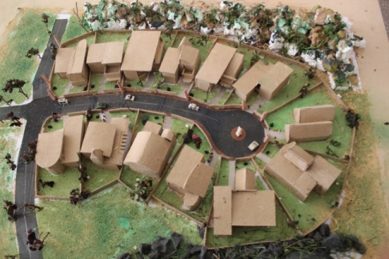\\\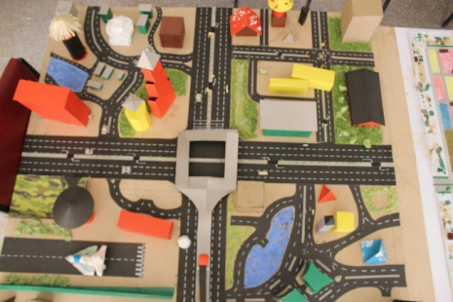

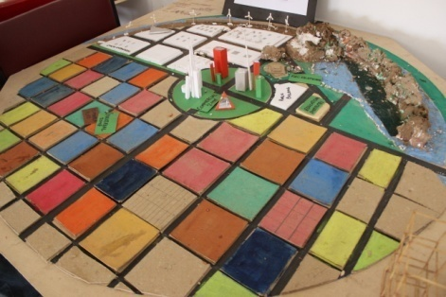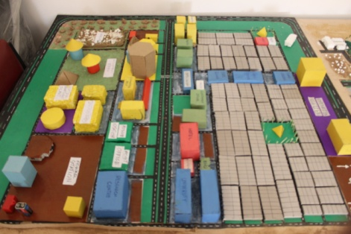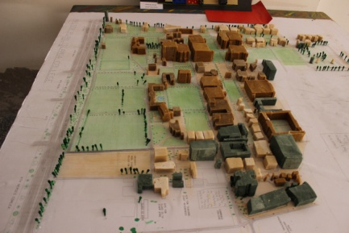

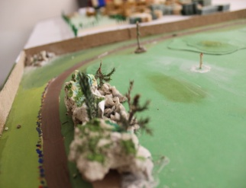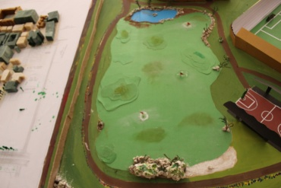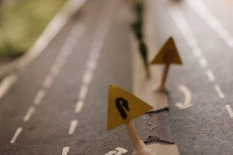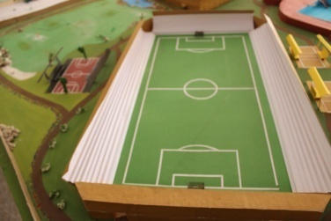

**The Final product- 3 D Models of all contesting groups**

**Day V Date: 22/02/2014**

9:00am-1:30pm: - Final touching in models

1:30 am-2:00pm:- Submission of models

2:00pm-3:30pm: -Model exhibitions

3:30pm-5:00pm:- Closing ceremony

In the morning session all ten groups of the participants gave final touches to their 3D models and presented that to Jury in the Afternoon session. The Jury comprised of:

Prof. Dr. Aslam Khan

Arch. Fahmidullah Shah

Arch. Arshad Khan

The Jury visited every group work individually and asked questions about the idea, presentation and materials used. After that the Chief Guest, Prof Dr Rasul Jan, Vice Chancellor, University of Peshawar along with Engr. Niaz Mohammad of USAID visited the workshop and went through the individual work of the participant. They appreciated the good work and ask question about the individual projects.

After this event a formal closing ceremony was started with the recitation from the Holy Quran. The Coordinator Urban and Regional Planning thanked the Chief Guest and other worthy guests and participants for gracing the occasion with their presence.

Afterward guest and students were invited to the podium to record their views about the event. Firstly Architect Fahmidullah Shah came and appreciated the organizer for holding this brain storming and creative activity. He illustrated that considering the level of skill of the participants on the day one of the workshop, it was an amazing improvement and the participants have learnt the art quite quickly. He appreciated the Institute for providing youngsters this opportunity.

Then Engr Niaz Mohammad of USAID shared his views both as an organizer as well as a visitor. He acknowledged the good work and reassured the full support and commitment of USAID Pakistan for any such activity that would boost the skill of youths of the nation.

In the end the Vice Chancellor in his presidential speech thanked the Urban Policy Unit Peshawar, USAID Pakistan and the Institute of Geography, Urban and regional Planning for giving opportunity to learn these tools of expression. He stressed upon the students as well to work hard to excel in their career and play their due role in national development. He advised the faculty as well to explore avenues like USAID and these should be further taped to get the essential funding for any such event in future as well.

The participants enjoyed five days of the workshop and After the speech of the Chief Guest result of the jury was announced and group 3 Comprising of students from Urban and Regional Planning and CECOS university got the first position with a cash award of Rs. 10,000/= Group 5 were runner up and got a cash prize of Rs. 5000/=. Besides, on the recommendation of the Jury, each group was given Rs. 1000/= as a consolation prize.

*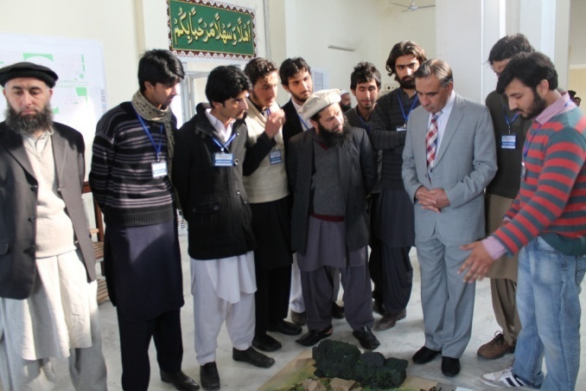*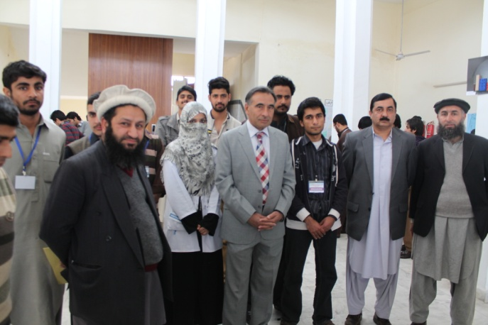

**Peshawar university VC,Director of Geography and URP, Dr syed Akhtir ali and students group photo**

*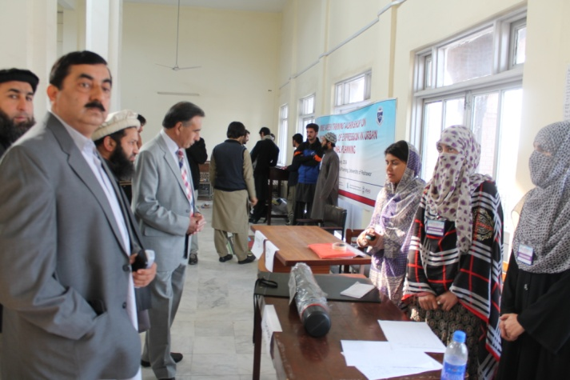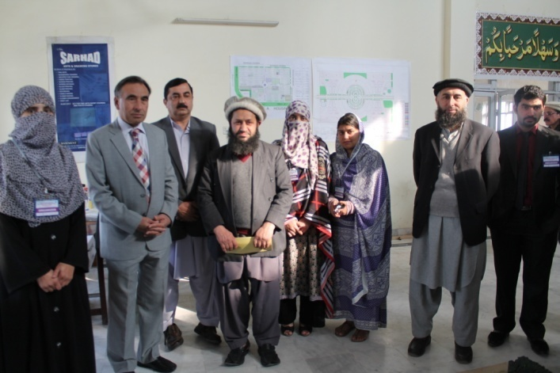*

**Engr Niaz Mohammad (USAID) Dr S. Akhtar Ali Shah (Coordinator) and the VC (UOP) visiting the stationary stall**

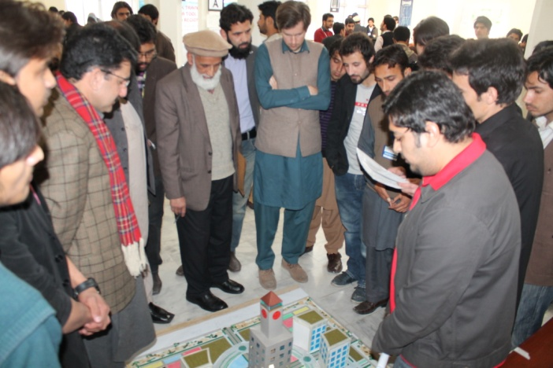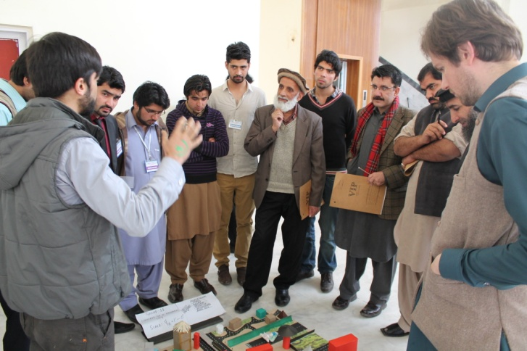

**Contesting groups presenting their work to the jury**

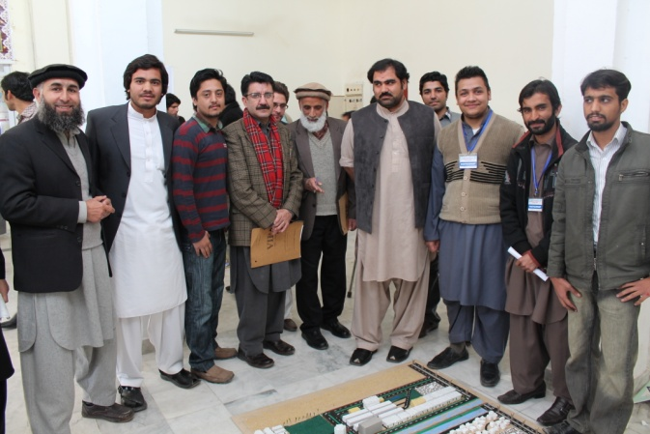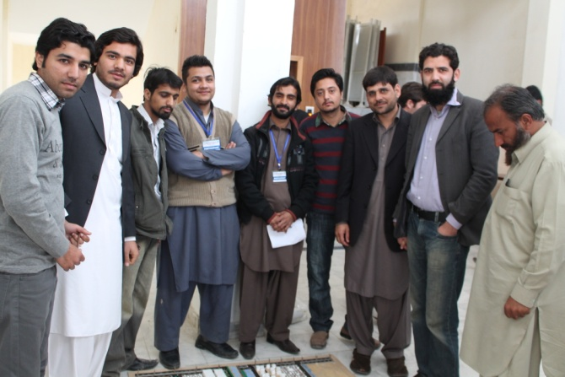

**Director of the Institute DrFazulrehman in a group photo with the Participants and the Jury**

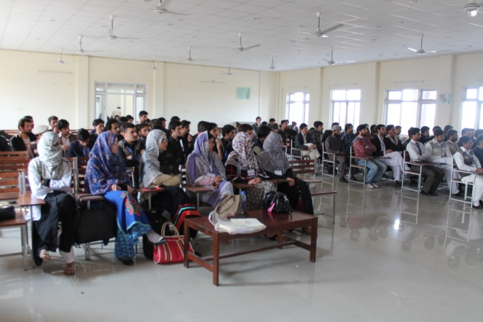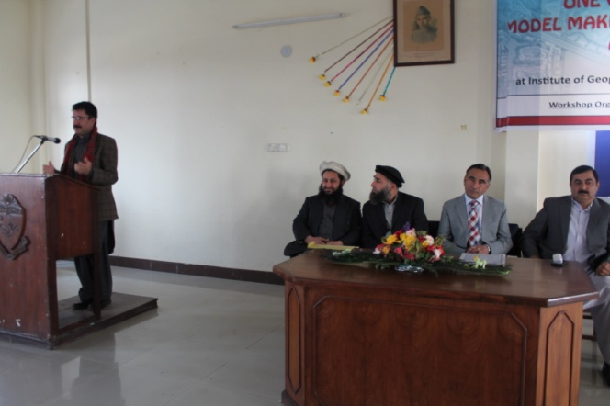

**Chairman Architecture department Hazara university sharing his views about the workshop output.**

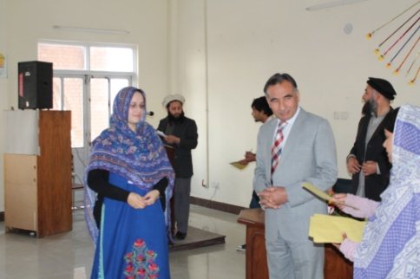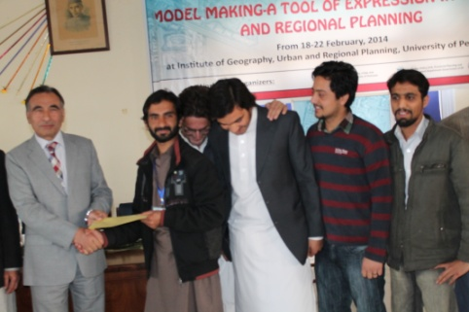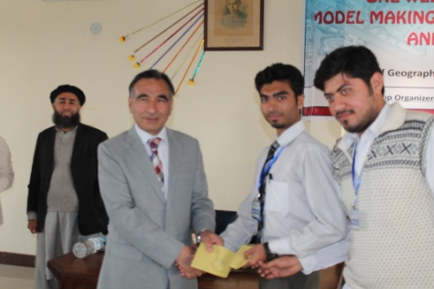

scdf

**Workshop participants and organizers receiving certificates and prizes from the Chief Guest**